

**Nominations for Awards**

We invite nominations for Division 24 Awards: ***The Award for Distinguished Theoretical and Philosophical Contributions to Psychology*, *The Sigmund Koch Award for Early Career Contribution to Psychology*, *The Theodore Sarbin Award*, and *The Distinguished Service Award***. Details about the awards and former recipients are available on the Division website: [www.theoreticalpsychology.org](http://www.theoreticalpsychology.org);)

In 2007, the **Joseph B. Gittler Award** was established through a bequest from Dr. Joseph Gittler. The award acknowledges scholarly contributions to the philosophical foundations of psychological knowledge. Self-nominations are welcome. Nomination materials may be submitted online at <http://forms.apa.org/apf/grants/>, or may be coordinated and collected by the nominator and sent to:

**APF Joseph B. Gittler Award   
American Psychological Foundation   
750 First Street, NE, Washington, DC 20002-4242.**

**Nominations for Officers**

As terms expire and open again to nominations, we would like to invite appropriate nominations from members.

I would like to invite our members to nominate officers to serve the Society on its executive committee. Two positions are open. First, the position of **President of Division 24 for 2011-2012** – a one year position- will need to be filled to replace John Christopher, who is currently **President-Elect** and will be President for the year 2010-2011.  Secondly, the position of **Board Member-at large**- a three year position – will need to be filled to replace Jamie Walkup. Please send your nominations for either or both of these positions to [kmalone@westga.edu](mailto:kmalone@westga.edu) or [kareenrormalone@gmail.com](mailto:kareenrormalone@gmail.com) . (This is my back-up email address to circumvent the spam blocker at university) or mail me a note with your nomination to Kareen Malone,  Department of Psychology,  Melson Hall, University of West Georgia, Carrollton, GA. 303118, USA.  I may also be reached by phone at 678-839-0616.

**Student Professional Support Fund**

The fund was established to help students with expenses related to attending the APA conventions. Please consider contributing to these funds as they are essential to the vitality of the Division. Mail donations to Dr. Amy Fisher Smith, Associate Professor, Department of Psychology. Office: 105 Augustine Hall. Telephone: 972-265-5731. Her mailing address is: 1845 East Northgate Drive, Irving University of Dallas 1845 East Northgate Drive, Irving, TX 75062-4736.

**Apportionment Ballots**

Please fill out and return your apportionment ballots allotting all of your votes (10) to Division 24. Reminder postcards are already in the mail.

**Annual APA Convention 2010**

Thank you to Dr. Naomi Lee for accepting the position of program chair. Naomi received her PhD from Georgetown University. She is currently a post-doc at the University of Wisconsin at Madison, and has co-authored a book with Fathali Moghaddam and Rom Harré on global conflict and positioning.

Remember to reserve the dates August 12-15, 2010. The convention will be held in San Diego, California. See details in the President’s Letter.

Please note there has been some controversy over the Manchester Hyatt Hotel in San Diego due to the “owner’s” activism against gay rights (regarding marriage), the hotel’s non-union status, and certain labor practices of the hotel. The APA has not decided to boycott the hotel as suggested by some divisions, however, a program on these issues is actively being pursued.

Our division, through executive committee deliberations, decided to follow this decision. If someone wants to pursue further involvement, please let Kareen know, and she will try to find out the best contact persons at APA. We also welcome papers addressing these issues.

“Yet, analytical truth is not as mysterious, or as secret, so as to not allow us to see that people with a talent for directing consciences see truth rise spontaneously.”

--Jacques Lacan

APA Division 24

Society for Theoretical and Philosophical Psychology

**www.theoreticalpsychology.org**

Fall Newsletter for Division 24

American Psychological Association

Society for Theoretical and Philosophical Psychology

C:\Documents and Settings\Nonah Elliston\Local Settings\Temporary Internet Files\Content.IE5\OEU6PCYA\MCj01050480000[1].wmf

**Announcements**

October 2009



Dear Colleagues,

The annual Fall Newsletter is written at the very beginning of my term as President. Part of the beginning is receiving a gavel, but it is also beginning to imagine the Society’s program for the next annual APA meeting. So to start I must mention Naomi Lee, our chair for the Division program, who is planning with me for the Annual APA Convention in San Diego on August 12-15, 2010. She and I have already secured our outside speaker, our first choice, Linda Alcoff. A little teaser on her work appears later in the newsletter. Before we discuss future plans, however, I want to extend a very well deserved thanks and appreciation for the fine work of President Barbara Held and Program Chair Michael Tissaw at 2009 annual APA convention in Toronto. Numerous posters, papers, and symposia presented by graduate students and distinguished senior scholars alike were included representing a wide mix of perspectives. Invited Speakers, such as Daniel N. Robinson, Michael Wertheimer (Winner of *Distinguished Theoretical and Philosophical Contributions to Psychology Award)* and Amie Thomasson, noted philosopher, as well as the Presidential Address generated discussion and showcased the erudition of our division. The Division’s journal, which as you know is now being published by the APA, will be moving to a quarterly journal by 2011. By the APA formula, its rejection rate is around 80%. Editor Thomas Teo and Associate Editor Jeff Sugarman continue to move the journal in new directions. *Please download articles from the journal from your library or other sources. Each download helps our royalties and thus the finances of the Division. Not to coin an oxymoron, perhaps we can generate a rigorous & scholarly revenue maker.* Our membership data suggest we may surpass last year’s totals, in part due to increasing student membership and affiliates. Our plan for next year’s conventions entails reaching out to other disciplines and international scholars. Our new student representative, Marissa E. Barnes, will be a most able interlocutor and recruiter to help the Division continue this trend of more student involvement.

Part of the purpose of this bi-annual Letter is to keep members apprised of important business and announcements of the Division. I would like to thank particularly Barbara Held, for her stewardship and kindness in the transition. I would like to thank Lisa Osbeck, Jeff Sugarman, Hank Stam, and Fred Wertz, all of whom have helped me assume this position and be of service to the Division. There are others I have not mentioned and all the executive committee has been most welcoming. I look very much forward to the upcoming year. Finally I want to thank Nonah Elliston for helping me with the newsletter and her involvement, as a student, with our Division’s labors.

Best Wishes,

Kareen Ror Malone, PhD.

President Division 24

Department of Psychology

University of West Georgia

* What can theoretical psychology add to the current social mix of differences, pluralism and the desire by the APA to be more inclusive?
* Are there any epistemological issues or methods at issue or is this merely an issue with no philosophical standing: a contingent and historical question?

Our keynote speaker will be Linda Alcoff known for her work in hermeneutics and feminism. She is a philosopher whose work should dovetail with many of the interests of the division. She has written extensively on diversity and all levels that it signifies.

Deadline for submissions to APA is December 1, 2009. Please see APA website at [www.apa.org](http://www.apa.org) and click the link under “Call for Programs.”

Please access registration information materials and the call for papers from the Division 24 website:

[*http://www.theoreticalpsychology.org/*](http://www.theoreticalpsychology.org/)*.*

Our first Mid-Winter meeting, two years ago, was a great success. These meetings offer a more intimate forum for the exchange of ideas and one can enjoy a little warmth away from northern winters. Please consider joining our next Mid-Winter Meeting.

.

Please extend heartfelt thanks to Professors Fowers and Slife and all who were involved in the work of making this meeting possible. Please attend, get students involved, and pass the word to others.

Please submit papers and symposia to our annual convention. The theme of the convention is diversity, intended at several levels including:

* Commensurability and incommensurability between paradigms within the Society of Theoretical and Philosophical Psychology. There are differences. How do we fructify from these differences rather than balkanize them?
* What is the nature of difference? How do we conceive difference or alterity/otherness in itself?
* How do we bridge differences with the mainstream: how do we distinguish yet communicate?

**Our second annual meeting is being held in Miami Beach, Florida on February 26-28, 2010.**

**Mid-Winter Meeting**

**Division Business Announcements**

The following is a disparate list of division 24 business items and information:

This August in Toronto, we took a final vote on changes in dues. The proposed change passed at the Business meeting. Dues will be increased from $29.00 to $35.00. Student dues remain $9.00; professional affiliate’s dues remain $20.00. Dues exempt members remain so but will pay $20.00 for a journal subscription.

In keeping with the duties stipulated in the By-Laws, the executive must notify membership of proposed changes to By-Laws:

The attending members of the 2009 meeting decided to propose that we change the moniker of our affiliate from “professional” to “scholarly” affiliate. I am announcing this possible change, to be voted on at next year’s business meeting. Reasons, in brief, to consider these changes are related to the type of affiliate we would in all likelihood attract (a scholar) and the practice connotations of “professional” within our discipline.

The executive board would like to propose moving to electronic voting. Voting electronically is becoming customary (no more hanging chads); also it is a more efficient and eco-friendly process. In 2007, APA by-laws were amended to allow electronic voting and I would like our membership to consider this amendment to our By-Laws so that electronic voting may be used for Division matters. The proposal will be voted on at the San Diego Business meeting.

John Carter has been designated Webmaster of the Division 24 Website. [*http://www.theoreticalpsychology.org/*](http://www.theoreticalpsychology.org/)*.* We all appreciate his hard work and the work of fellow web committee members on this very important project.

Finally, a hearty congratulations to those individuals elected to new offices within Division 24:

***President-Elect: John Christopher  
Secretary-Treasurer: Amy Fisher Smith  
Member-at-Large: Michael Tissaw***

Letter from the President

**October 2009**

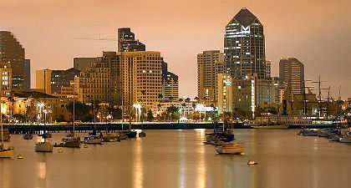

Downtown San Diego, CA

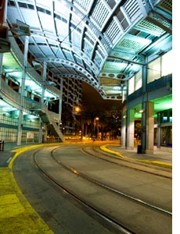

Public Transportation in San Diego.

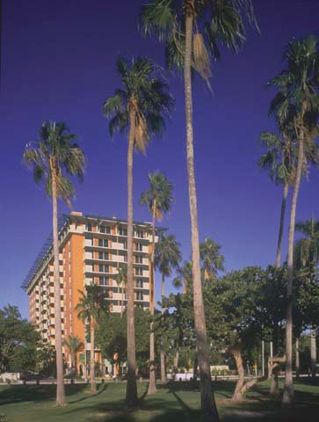

Mutiny at Coconut Grove Miami Beach, Fl

The sponsor hotel this year is the Mutiny Hotel of Coconut Grove. Reservations can *only* be made by phone: 888-868-8469. Early registration is essential. To get the group rate, please specify that you are attending the meeting of the Society for Theoretical and Philosophical Psychology. If you encounter a snag or have questions, please contact Blaine Fowers, who has graciously agreed to help with local arrangements, at [**bfowers@miami.edu**](mailto:bfowers@miami.edu)**.**

**Important: Deadline for call for papers is October 30,2009**

**For program questions, please contact Professor Brent Slife, email:**

[**slife@byu.edu<mailto:slife@byu.edu>**](mailto:slife@byu.edu)

**Annual APA Convention in San Diego on August 12-15, 2010**

**Linda Martin Alcoff (use stuff from here site. CONNECTING PEOPLE**